Sales of products in four different regions is tabulated for males and females. Find if male-female buyer rations are similar across regions
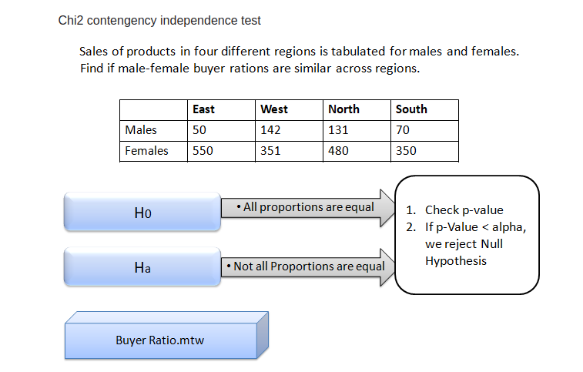

Assume Null Hypothesis as Ho: Independence of categorical variables (male-female buyer rations are similar across regions (does not vary and are not related) Thus Alternate Hypothesis as Ha: Dependence of categorical variables (male-female buyer rations are NOT similar across regions (does vary and somewhat/significantly related)
Inference: As (p-value = 0.6603) > (α = 0.05); Accept the Null Hypothesis i.e. Independence of categorical variables Thus, male-female buyer rations are similar across regions and are not related

